9. Travelling Salesman Problem (TSP)

Aim
To implement the Travelling Salesman Problem (TSP) using Python to find the minimum cost path that visits every city exactly once and returns to the starting city.

Algorithm
- Represent the cities using a cost matrix.
- Generate all possible routes.
- Calculate the total cost of each route.
- Select the route with the minimum cost.
- Display the shortest path and its cost.
Pseudocode
Start
Read cost matrix
Generate all possible paths
For each path
Calculate total cost
Select path with minimum cost
Display minimum cost and path
Stop

Code:
from itertools import permutations

graph = [
[0, 10, 15, 20],
[10, 0, 35, 25],
[15, 35, 0, 30],
[20, 25, 30, 0]
]

cities = [0, 1, 2, 3]
min_cost = float('inf')
best_path = None

for path in permutations(cities[1:]):
route = (0,) + path + (0,)
cost = 0

for i in range(len(route) - 1):
cost += graph[route[i]][route[i + 1]]

if cost < min_cost:
min_cost = cost
best_path = route

print("Best Path:", best_path)
print("Minimum Cost:", min_cost)
Output:
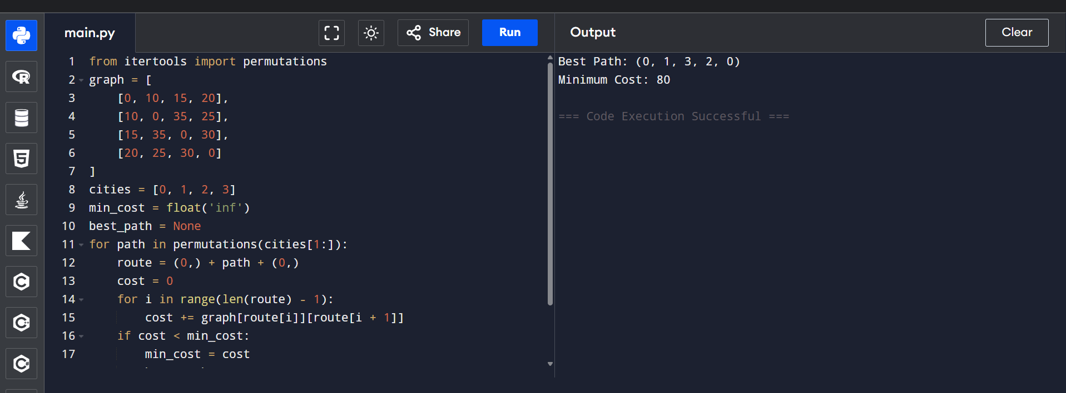

10. A* Search Algorithm

Aim
To implement the A* Search Algorithm to find the shortest path between two nodes.

Algorithm
- Create a graph and heuristic values.
- Insert the start node into the priority queue.
- Remove the node with the lowest cost.
- If it is the goal node, stop.
- Otherwise, visit its neighbors.
- Update the cost and add neighbors to the queue.
- Repeat until the goal is reached.
Pseudocode:
Start
Create graph and heuristic values
Insert start node into priority queue

While queue is not empty
Remove node with lowest cost
If goal reached
Display path
Stop
Visit neighbors
Update costs
End While

Stop

Code:

import heapq

graph = {
'A': [('B', 1), ('C', 3)],
'B': [('D', 3), ('E', 6)],
'C': [('F', 5)],
'D': [],
'E': [('G', 2)],
'F': [('G', 2)],
'G': []
}

heuristic = {
'A': 7,
'B': 6,
'C': 4,
'D': 3,
'E': 2,
'F': 1,
'G': 0
}

pq = [(heuristic['A'], 0, 'A')]
visited = set()

while pq:
f, cost, node = heapq.heappop(pq)

if node in visited:
continue

print(node, end=" ")
visited.add(node)

if node == 'G':
break

for neighbor, weight in graph[node]:
if neighbor not in visited:
heapq.heappush(
pq,
(cost + weight + heuristic[neighbor],
cost + weight,
neighbor)
)

Output:
